

Networking

PROJECT

Name: RAJIV K C KHATR

Course Title: COMPUTER NETWORKING

Date: 28/12/2018

**Definition - What does *Computer Networking* mean?**

Computer networking is an engineering discipline that aims to study and analyse the communication process among various computing devices or computer systems that are linked, or networked, together to exchange information and share resources.

Computer networking depends on the theoretical application and practical implementation of fields like computer engineering, computer sciences, information technology and telecommunication.

A network in computing is a group of two or more devices that can communicate. In practice, a network is comprised of a number of different computer systems connected by physical and/or wireless connections. The scale can range from a single PC sharing out basic peripherals to massive data centres located around the World, to the Internet itself. Regardless of scope, all networks allow computers and/or individuals to share information and resources.

1. Analysis of customer requirements.

|  |
| --- |
|  |
| Computer networks help users on the network to share the resources and in communication. Can you imagine a world now without emails, online newspapers, blogs, chat and the other services offered by the internet?  The following are the important uses and benefits of a computer network. |

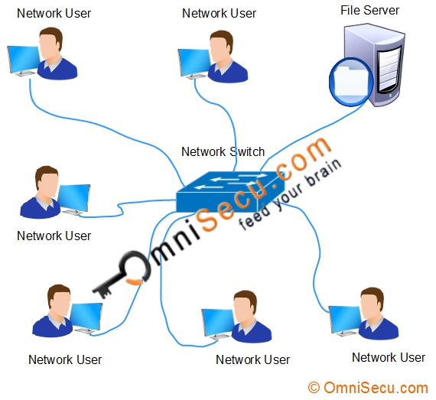

Network has no boundary and supports the way we:

• Learn • Communicate • Work •Online banking • World News • Information about traffic • Weather forecasts • e-learning • File exchange • E-mail • Google Earth • Other

* 1. wireless technology

▪ Mobile phones use radio waves to transmit voice signals to antennas mounted on towers located in specific geographic areas.

The abbreviations 3G, 4G, and 4G-LTE are used to describe enhanced cell phone networks that are optimized for the fast transmission of data.

Other networks that are used by smart phones include GPS, Wi-Fi, Bluetooth, and NFC.

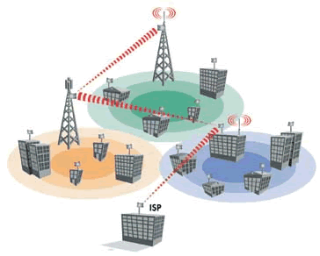

* 1. wired and cable network

A wired [network](https://techterms.com/definition/network) is a common type of wired configuration. Most wired networks use [Ethernet](https://techterms.com/definition/ethernet) cables to transfer data between connected [PCs](https://techterms.com/definition/pc). In a small wired network, a single [router](https://techterms.com/definition/router) may be used to connect all the computers. Larger networks often involve multiple routers or [switches](https://techterms.com/definition/switch) that connect to each other. One of these devices typically connects to a [cable modem](https://techterms.com/definition/cable_modem), [T1](https://techterms.com/definition/t1) line, or other type of Internet connection that provides Internet access to all devices connected to the network.

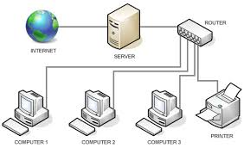

Links: google.com networking picture

2.0 Topologies

***Network Topology*** refers to the layout of a [network](https://www.webopedia.com/TERM/N/network.htm) and how different [nodes](https://www.webopedia.com/TERM/N/node.htm) in a network are connected to each other and how they communicate. Topologies are either physical (the physical layout of devices on a network) or logical (the way that the signals act on the network media, or the way that the data passes through the network from one device to the next). This five of the most common network topologies.

* [Network](https://www.webopedia.com/TERM/N/network.html)
* [Topology](https://www.webopedia.com/TERM/T/topology.html)
* [Node](https://www.webopedia.com/TERM/N/node.html)
* [Physical Topology](https://www.webopedia.com/TERM/P/physical_topology.html)
* [Logical Topology](https://www.webopedia.com/TERM/L/logical_topology.html)

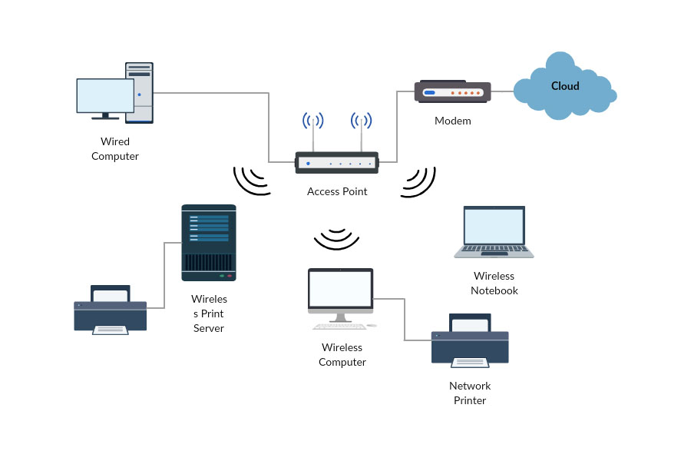

2.1 sub-networking

Computers that belong to a subnet are addressed with an identical [most-significant bit](https://en.wikipedia.org/wiki/Most-significant_bit)-group in their [IP addresses](https://en.wikipedia.org/wiki/IP_address). This results in the logical division of an IP address into two fields, the *network number* or *routing prefix* and the *rest field* or *host identifier*. The *rest field* is an identifier for a specific [host](https://en.wikipedia.org/wiki/Host_(network)) or network interface.

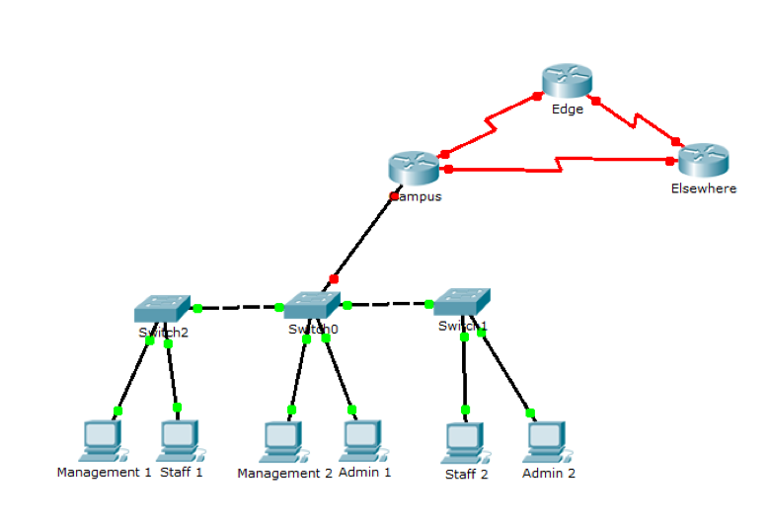

Objectives:

How to install, configure, and troubleshoot a computer network ▪ Protocols and standards ▪ Routing ▪ Topologies ▪ Hardware ▪ Network operating systems ▪ Cisco IOS

Types of Media

▪ There are many different Physical layer implementations that support multiple media types:

▪ UTP (Category 5, 5e, 6, and 7)

▪ Fiber-optics ▪

Wireless Each media type has its advantages and disadvantages

▪ Cable length

▪ Cost

▪ Bandwidth

▪ Ease of installation

▪ Susceptible to EMI/RFI

WAN and LAN.

It simplifies network security management by centralizing information collection warning and features that ensure high availability and balance and managing rule configuration from one console. Thanks to the optional and the ability to connect tens of thousands of nodes, meets the performance requirements of companies and institutions any size the file server role is fulfilled by the DELL PowerEdge 1950 QUAD with the following parameters: Quad-Core

Xeon 2330; 16GB 667MHz FBD (8x2GB dual rank DIMMs); 2 x 250GB SATA2 hard disk connected in

The server operates under the control of the Linux operating system along with the Samba software

SWAT, WINS and ProFtpd FTP Server

The role of the apache server is met by DELL PowerEdge 2650 with the parameters 2 x Xeon 2800Mhz, 2 x 36GIB

Hard Drive: 2GB Ram, CD, FDD

The server operates under the control of the Linux operating system together with the Postfix Mail software

Server, Apache Web Server

Dell PowerEdge 1750 performs the role of an administration spencer with parameters. 1 x Pentium Xeon

2.4ghz, 512mb ram, 1 x 36gb HDD, CDROM, FDID

Servers operate under the control of the Linux operating system.

The connection between the ends of the computer network and switches is based on the 100-BaseT network

Fast Ethernet Between servers and Router and switch is implemented as a 1000-BaseT Fast Ethernet in accordance with the assumptions, the building will be fitted with enabling devices wireless access to the local network and the Internet. There are 3 LINKSYS devices

WAP54G. Specification:

possibility of working in modes: mixed, 802.11g. 802.11h

WEP, WPA

provides: roaming, selecting the best access point, balancing the load (load balancing) and packet traffic filtering can work as an access point, bridge (point-to-point or point-to-multipoint), another AP client (AP Client) and repeater in bridge mode it is possible to connect 4 other access points access / access point access table based on MAC addresses (50 items)

web management creating logs of the access point activity that records all unauthorized attempts access, customer activity, possible problems their installation under the ceiling will cover the whole school

All network components are connected by Cisco switches: 48 port model 2950 and Catalyst 4908G-L3 8x. They are all used for mounting in 19 "rack cabinets. other grapevines: white-orange, orange, white-green, blue, white-blue, green, white brown and brown. Cables should be done in-house,

one of the two previously described standards. To perform we will use the STP cable due to the minimization of interference. Benefits stance and holding on a crimp is needed. We It is simple in monitor, it is characterized by a large bandwidth of up to 1000Mb / s

Easy diagnosis of faults

It gives big possibilities for expansion (modular construction)

- Cable failure in one place does not immobilize the entire network

It has a very advantageous ratio of possibilities to Connections inside the building will be made with STP cat. 5e cable (It can carry signals about frequency up to 100 Mhz. Thanks to this, it is possible to use the Fast internet network technology,

enabling data transmission at speeds up to 1000 Mbps (1Gbit's Ethernet).

Cable routes

with mechanical damage, as well as ensure easy access to work if necessary, maintenance, and Cables in office rooms are placed in PVC mounted wiring trays

horizontally on the walls. Similarly, we combine distribution cabinets located on different floors

and Access point devices It must be avoided that the cable is not Sharpe will be so as to minimize related problems as much as possible adjust the system for future expansion

For connecting computers via a switch, the so-called straight cable, in both plugs

the cables are connected equally.

Plugin 1

1. white and green

2. green

3. white-orange

4. blue

5. white and blue

6. orange

7. white-brown

8. brown

Plug 2

1. white and green

2. green

3. white and orange

4. blue

5. white-blue

6. orange

7. white-brown

8. brown

Next is CROSS OVER UTB cable (RJ-45 CONNECTOR)

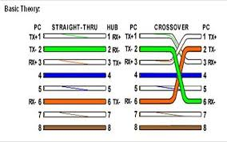

Plugin 1

1. white and green

2. green

3. white-orange

4. blue

5. white and blue

6. orange

7. white-brown

8. brown

Plug 2

1. white and orange

2. orange

3. white and green

4. blue

5. white and blue

6. green

7. white-brown

8. brown

▪ Typically, when connecting different types of devices, use a straight-through cable A straight-through cable has connectors on each end that are terminated the same in accordance with either the T568A or T568B standards. When connecting the same type of device, use a crossover cable. crossover cables directly connect the following devices on a LAN: Switch to switch to hub to hub Router to router Ethernet port connection Computer to computer to a router Ethernet port.

Routers

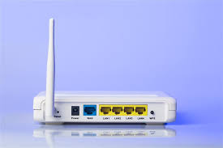

Routers offer many services, including internetworking and WAN interface ports, Modems include interfaces voice services, channel service units/digital service units (CSU/DSUs) that interface T1/E1 services, and Terminal Adapters/Network Termination 1 (TA/NT1s) that interface Integrated Services Digital Network (ISDN) services. Communication servers concentrate dial in and dial out user communication.

Host Routing Tables Default Gateway

Hosts must maintain their own, local, routing table to ensure that network layer packets are directed to the correct destination network the local table of the host typically contains: Direct connection Local network route Local default routers

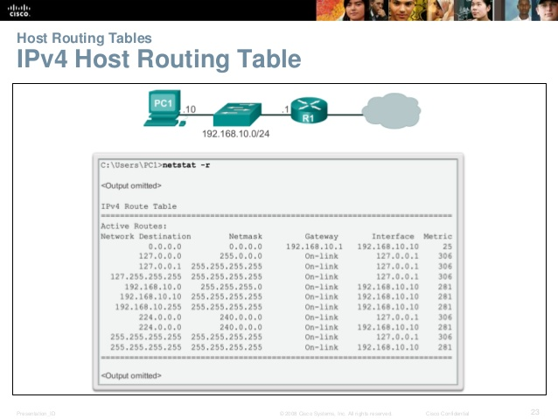

Router Boot-up Cisco IOS

The Cisco IOS operational details vary on different internetworking devices, depending on the device’s purpose and feature set. However, Cisco IOS for routers provides the following: Addressing, Interfaces Routing, Security, QoS, Resources Management

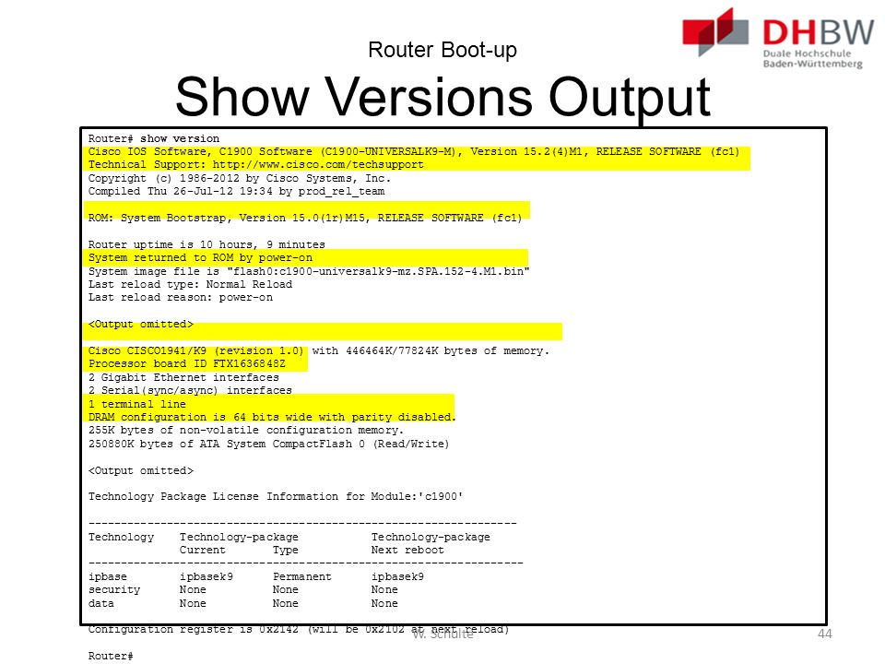

Configuring a Cisco Router: 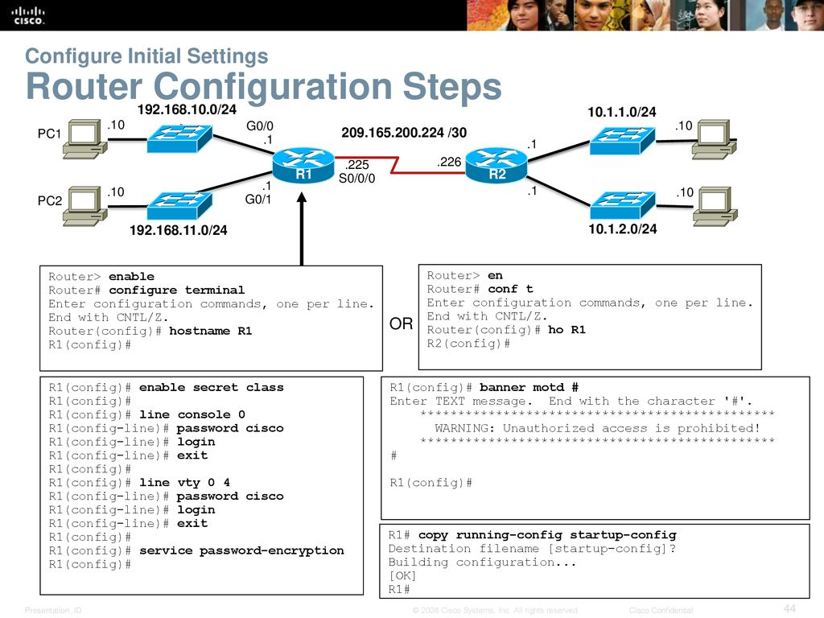

Configure Interfaces Configure LAN Interfaces:

R1# conf t Enter configuration commands, one per line. End with CNTL/Z.

R1(config)#

R1(config)# interface gigabitethernet 0/0

R1(config-if)# ip address 192.168.10.1 255.255.255.0

R1(config-if)# description Link to LAN-10

R1(config-if)# no shutdown %LINK-5-CHANGED: Interface GigabitEthernet0/0, changed state to up %LINEPROTO-5-UPDOWN: Line protocol on Interface GigabitEthernet0/0, changed state to up

R1(config-if)# exit

R1(config)#

R1(config)# int g0/1

R1(config-if)# ip add 192.168.11.1 255.255.255.0 R1(config-if)# des Link to LAN-11

R1(config-if)# no shut %LINK-5-CHANGED: Interface GigabitEthernet0/1, changed state to up %LINEPROTO-5-UPDOWN: Line protocol on Interface GigabitEthernet0/1, changed state to up

R1(config-if)# exit

R1(config)

Configuring the Default Gateway Default Gateway on a Switch 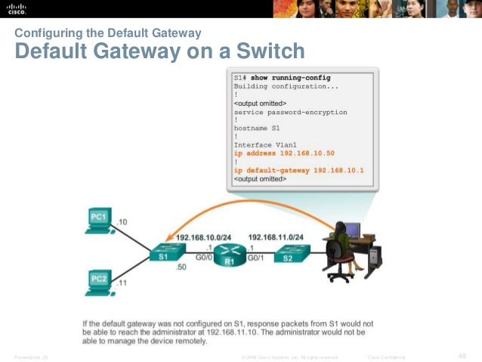

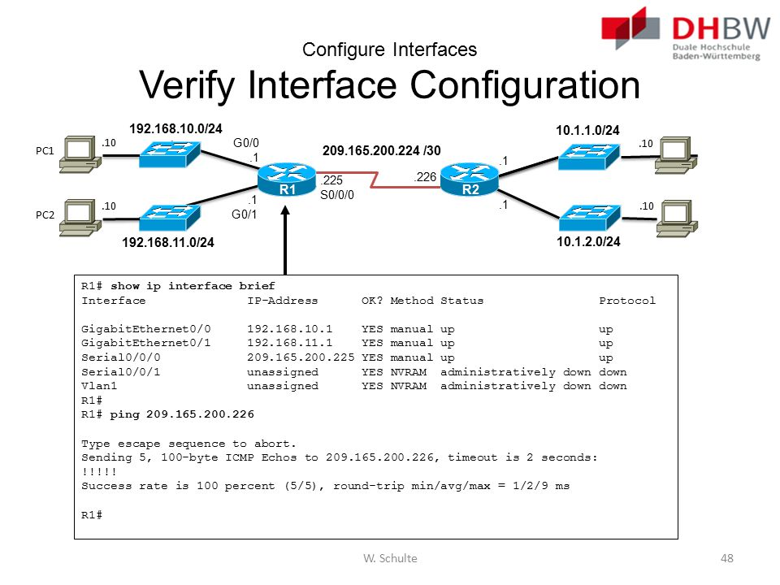

Configure Interfaces Verify Interface Configuration:

**Basic Router Configuration**

Information from the show interface

Basic tasks

1. ▪ Router > enable Password: ▪ Router# configure terminal ▪ Router(config)# ▪ Type exit from one of the specific modes to return a router to global configuration mode ▪ Router(config)#exit ▪ Router#
2. ▪ Naming the router ▪ Setting passwords (password cisco) ▪ Configuring interfaces ▪ Configuring a banner ▪ Saving changes on a router ▪ Verifying basic configuration and router operations
3. ▪ Connect a router and workstation using a console cable. ▪ Configure Putty to establish a console session with the router ▪ Log into the router (If prompted for a password, enter cisco) ▪ Check show commands on the router ▪ (show version, flash, interface, … etc.) ▪ Use the HELP feature (by typing the?) ▪ Enter privileged EXEC mode ▪ Examine the running configuration ▪ Check, how much main, shared, DRAM memory is installed in the router? ▪ Configure an enable password of „cisco”
4. • Configure a hostname „Perth” • Configure an IP address for Ethernet 0/0 interface • Configure an IP address for Serial 0/0 interface • Active the interface • Display the active configuration in DRAM, NVRAM, • Check, IOS release running on router • Try to ping router’s interface from PC and vice versa. • Logoff and turn the router off

Binary Numbers

**Objectives**

1. **Convert IPv4 Addresses from Dotted Decimal to Binary**
2. **Use Bitwise ANDing Operation to Determine Network Addresses**
3. **Apply Network Address Calculations**

**Background / Scenario**

Every IPv4 address is comprised of two parts: a network portion and a host portion. The network portion of an address is the same for all devices that reside in the same network. The host portion identifies a specific host within a given network. The subnet mask is used to determine the network portion of an IP address. Devices on the same network can communicate directly; devices on different networks require an intermediary Layer 3 device, such as a router, to communicate.

To understand the operation of devices on a network, we need to look at addresses the way devices do—in binary notation. To do this, we must convert the dotted decimal form of an IP address and its subnet mask to binary notation. After this has been done, we can use the bitwise ANDing operation to determine the network address.

This lab provides instructions on how to determine the network and host portion of IP addresses by converting addresses and subnet masks from dotted decimal to binary, and then using the bitwise ANDing operation. You will then apply this information to identify addresses in the network.

**Use Bitwise ANDing Operation to Determine Network Addresses**

In Part 2, you will use the bitwise ANDing operation to calculate the network address for the provided host addresses. You will first need to convert an IPv4 decimal address and subnet mask to their binary equivalent. Once you have the binary form of the network address, convert it to its decimal form.

**Note**: The ANDing process compares the binary value in each bit position of the 32-bit host IP with thecorresponding position in the 32-bit subnet mask. If there two 0s or a 0 and a 1, the ANDing result is 0. If there are two 1s, the result is a 1, as shown in the example here.

**Step 1: Determine the number of bits to use to calculate the network address.**

|  |  |  |  |  |  |  |  |  |
| --- | --- | --- | --- | --- | --- | --- | --- | --- |
|  | **Description** |  |  | **Decimal** |  |  | **Binary** |  |
|  |  |  |  |  |  |  |  |  |
|  | IP Address | | 192.168.10.131 | |  | 11000000.10101000.00001010.10000011 | |  |
|  |  | |  | |  |  | |  |
|  | Subnet Mask | | 255.255.255.192 | |  | 11111111.11111111.11111111.11000000 | |  |
|  |  | |  | |  |  | |  |
|  | Network Address | | 192.168.10.128 | |  | 11000000.10101000.00001010.10000000 | |  |

Example:

Sample for project

Rajiv K C Khatri: We decided to access the Internet through a fast core network implemented in technology,

Distribution points are used to install active network hardware (e.g. routers) and the market distribution point (BPD) is the place where all cables come together consisting of a network centre point (np cables) Bu vertical, as well as the place of concentration of the equipment main switches, central router, etc.)

Section of the building

100 m

Ground floor

1st floor

2nd floor

• Dimensions about 20 m x 100 m • 3 floors, floor height 4m • 3-5 connections in each room • About 20 rooms per floor

cabling

1A1 1A12 1A21 1A2 1A3 / 1A3 / 2 1A4 / 1 6 16.5 20.5 20.5 1A52 1AB / 1 1A6 / 2 1A7 / 1 1A7 / 2 1A8 / 1 32.5 181 / 181/2 1B2 / 1 182/2 183/1 1B3 / 2 39.5 8 1C1 / 1 1C1 / 2 1C2 / 1 1C22 1D1 / 1 1D1 / 2 102/1 9 103/2 1E1 / 1 1E1 / 2 1F1 / 1 1 F1 / 2 27 1081 meters

The length of the cable going to the network sockets (m) –

ground floor 2H1 / 2 2H2 / 1 2H2 / 2 2H3 / 2H3 / 2 2H4 / 1 2H4 / 2 14.5 15 20.5 30 30 35mm 36 -_- 35.5 2H5 / 1 2H5 / 2 2H6 / 1 2H6 / 2 2H7 / 1 1 2H92 2H10 / 1 2H10 / 2 2H11 / 1 2H1 1/2 2H12 / 1 2H12 / 2 35.5 21/1 211/2 212/1 212/2 213/1 2K1 / 12K1 / 2 50 2K2 / 1 2K2 / 2 1L1 / 1 1L12 2M1 / 1 2M1 / 2 45.5 1199 meters 2P2 / 1 2P2 / 2 2P3 / 1 2P3 / 2 2P4 / 1 2P4 / 2 2P5 / 1 2P5 / 2 2P6 / 1 2P6 / 2 2P7 / 1 2P7 / 2 2P8 / 1 2P8 / 2 2P9 / 1 2P9 / 2 2P10 / 1 2P10 / 2 2P11 / 1 2P11 / 2 2P12 / 1 2P122 2R1 / 1 2R1 / 2 2R2 / 12R22 2R3 / 1 2R3 / 2 4 / 2R4 / 2 3U1 / 2

The length of the cable going to the network sockets (m) –

1st floor 5 15.5 20.5 20.5 35.5 35.5 43 50 3S1 / 2 3T1 / 1 3T1 / 23T2 / 3T2 / 2 3U1 / 1 50 57 45.5 45.5s 3W1 / 1 3W 1/2

Sum: 1327 meters

The length of the cable going to the mains sockets (m) -2nd floor The tables above show the ductility of wires from distribution points to points subscriber. Each piece of horizontal cabling has been accurately measured and a reserve of 1.5 has been added m, to overcome the inevitable errors of measurement, the total length of 3607m wiring Internet access,

Frame Relay

Short characteristics

download speed: up to 20480 kb / s (20 Mb / s)

- speed of sending data: up to 2048 kb / s

number of public IP addresses: 5

the data download limit is missing

Before network users can use the internet, we need to configure the server accordingly

We will start with the installation and configuration of the terminal. Computers through the Linux server will be obtained

Internet access

The internet provider of our investor will give him 5 pools of IP addresses. The computers in the local network will be

had internet connection via address translation (NAT)

1. Any configuration is based on the configuration of several Linux files. First, check if it exists

file etc. / sys config / network-scripts / chat-pppo. If it is not there, you have to create it and fill it with two

apostrophes ("). Nothing else can be in it. As part of the TP SA service, we were given a login

username123, password123 and the IP address 122.233.234.235, 2. Now we have dealt with the file

pap-secrets

which also needs to be cleared. We enter only data about our connection with

SDI, or login, and after a star, the password and IP address assigned by TP SA. We separate each position

space. It looks more or less the same way:

root @ Hell Gate root # cat / etc. / ppp / pap-secrets

# Secrets for authentication using PAP

# client server secret his123.

HASL0123 122 233.234.235

3. In the /etc./crud directory, we need to create a script that will run the daemon

pppd

Internet connection. Let's call, He has this content:

root @ Hell Gate root) # cat. username

# 1 / bin / sh

pppd / devitty So 115200 modem default route lock crusts nautch user his115

5. The last step is to define the list of DNS servers of our service provider, the Internet

(in this case, TP SA). In the file let / re-silicone, enter

[root @ Hell Gate rotgut cat /etc/resolv.config

nameserver 194.204.152.34

nameserver 194.204.159.1

6. From now on, we can connect to the Internet, calling from a console created earlier

To automate the process, add at the end of the letc / rc file. d / rc local script:]: then letc / rc.d'rc his f

This will automatically connect at the system startup

The structure of addressing computers in the network

to give IP addresses to individual computers in the local network. use should be private address classes These are pools of IP numbers that can be used freely in local networks new in those connected to the boarding school. list can be found in tables. In small lattice networks C class is most often used

Class A 10.0.0.0-10.255 255.255 255.0.0.0 255.255.0.0 255.255.255.0 Class B 172.16.0.0-172 31.255.255

Class C 192.168.0.0-192.168.255.255 In a LAN, we can use one of the three private address classes visible above. It is recommended that. would when assigning addresses to individual hosts on the network device that performs the function of an interphone gate, the router server's server should have the first one free address from a given address class. So, for class C, choose 192.168.0.1. Next free reserved they are for servers with other, important roles in the network. Only we assign the rest of IP addresses to clients in network. For the given address pool, we have adopted the mask 255 255 255.0, which gives us 254 motorcycles, counting one address per goal. To be able to print on printers h, they must also have an assigned IP address. Access from outside to printers is unnecessary, so they will be assigned addresses from a private pool, the same as computers, so male in the case of switches and access points. Although the access point does not need to be useful green IP, with reason we assign them a yes2 to them that is the bridge in the transmission between the networks, in order to have the possibility of them IP constantly. We do the same for switches - they are an additional configuration option via the www panel IP numbers can be assigned during Linux installation or later with the help of the program netconfig. We run it with the netconfig command in the command line. Every computer on the network must have a different IP address and the same subnet mask. Netconfig will guide us step by step in configuring the interface configuration Additional property amenities This requires at least one DNS server provider's DNS address For TP SA clients, these are: 194,204,154 and 194 204.159.

1 Computer IP addresses Gateway server (router) -192.168 01

Apache-192.168.0.2

server File server (backup) - 192.168.03

Administration server 192.168 0.4

Firewall 192.168.05

Switch S1-192.168.0.6

Switch S2-192.168.0.7

Switch S3-192.168.0.8

Switch S4 192.168.0.9

Access point 1-192. 168.0.10

Access point 1-192.168.0.11

Access point 1-192.168.0.12

Printer 1 -192.168 0.13

Printer 2-192.168.0.14

Printer 3-192 1680.15

Printer 4-192.168.0.16

Printer 5-19.168.0.17

Printer 6-19.168.0.18

Printer 7-192.168.0.19

com1 192.168.0.21

com2-192.168.0.22

com3 192 168.0 23

com4- com9 - adequate as above

E.g. for computer no. 50 IP 192 168.070

Building

100m length

20m Hight

|  |  |  |  |  |  |  |  |  |  |  |  |  |  |  |  |  |  |
| --- | --- | --- | --- | --- | --- | --- | --- | --- | --- | --- | --- | --- | --- | --- | --- | --- | --- |
| |  |  |  |  |  | | --- | --- | --- | --- | --- | |  |  |  |  |  | |  |  |  |  |  | |  |  |  |  |  | |  |  |

Ground floor

|  |  |  |  |  |  |  |  |  |  |  |  |  |  |  |
| --- | --- | --- | --- | --- | --- | --- | --- | --- | --- | --- | --- | --- | --- | --- |
|  | |  |  |  |  | | --- | --- | --- | --- | |  |  |  |  | |  |  |  |  | |  |  |  |  | |  |

1st floor

|  |  |  |  |  |  |  |  |  |  |  |  |  |  |  |
| --- | --- | --- | --- | --- | --- | --- | --- | --- | --- | --- | --- | --- | --- | --- |
|  | |  |  |  |  | | --- | --- | --- | --- | |  |  |  |  | |  |  |  |  | |  |  |  |  | |  |

2nd floor

|  |  |  |  |  |  |  |  |  |  |  |  |  |  |  |  |  |  |  |  |  |  |  |  |  |  |  |  |  |  |  |  |  |  |  |  |  |  |
| --- | --- | --- | --- | --- | --- | --- | --- | --- | --- | --- | --- | --- | --- | --- | --- | --- | --- | --- | --- | --- | --- | --- | --- | --- | --- | --- | --- | --- | --- | --- | --- | --- | --- | --- | --- | --- | --- |
| |  |  |  |  | | --- | --- | --- | --- | |  |  |  |  | |  |  |  |  | | |  |  |  |  | | --- | --- | --- | --- | |  |  |  |  | |  |  |  |  | | |  |  |  | | --- | --- | --- | |  |  |  | |  |  |  | | |  |  |  |  | | --- | --- | --- | --- | |  |  |  |  | |  |  |  |  | |  |  |  |  | |

Preliminary schedule list of sockets, cables, devices etc

The cost of network equipment

Switch Catalyst Cisco 4908G-L3 8x

Switch Catalyst Cisco 2950 48 ports 2950

Linksys BEFSR81-EU Router

Symantec Gateway Security 5400

STRP network cable

RJ46 plugs

Network

42u

10u wardrobe

DELL PowerEdge 1950

DELL PowerEdge 1750

Deli PowerEdge 2650

MAXVIEW KVM server management console

UPS ORVALDI 300ORT sin rack

PATCHPANEL 19 1U 50 ports

The cost of office equipment and servers

Equipment

single price amount

Workstations

Monitor

Projector Epson EMP-X5 +

HP LaserJet 1020 printer

W-F HP Officejet Pro L7780 Wi-Fi

Labour

Hiring a worker

Internet access

installation

- activation

- Internet access for ultra 20/2 Mb / s

Total cost=around 8,00,000.00 Nepalis rupees

So,

Monitor

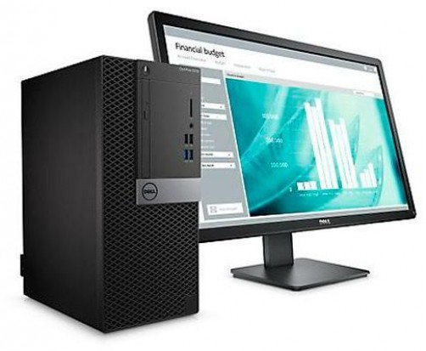

Printer

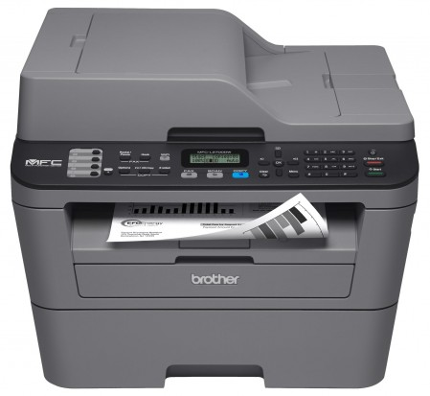

Projector

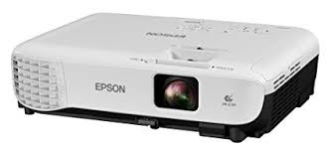

Cisco catalyst 4908

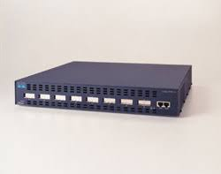

Symantec gateway security

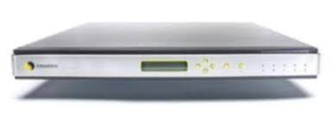

Dell power edge

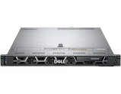

Thank you

References:

1.Source of picture= Google/picture.com

2.Source of book=J. F. Kurose and K. W. Ross, Computer Networking A Top-Down Approach, 7th edition, Pearson, 2017 and Networking

3.Teacher lecture note

4.www.google.com

Good bye…………………